

***CONTAINERS AND DOCKERS***

***Submitted by:***

***NAME: Tanishqua Tellakula***

***SAP ID: 500084269***

***Roll number :R120220007***

***Batch: B1(Hons)***

***Lab Exercise 5- Building a Docker Image for an HTML App Using Nginx***

***1. Setup***

*You will need:*

* *Docker installed on your machine.*
* *A simple HTML file for the app.*

***2. Step 1: Create the HTML File***

*Create a directory for your HTML app and place an index.html file in it.*

|  |
| --- |
| ***mkdir nginx-html-app***  ***cd nginx-html-app*** |

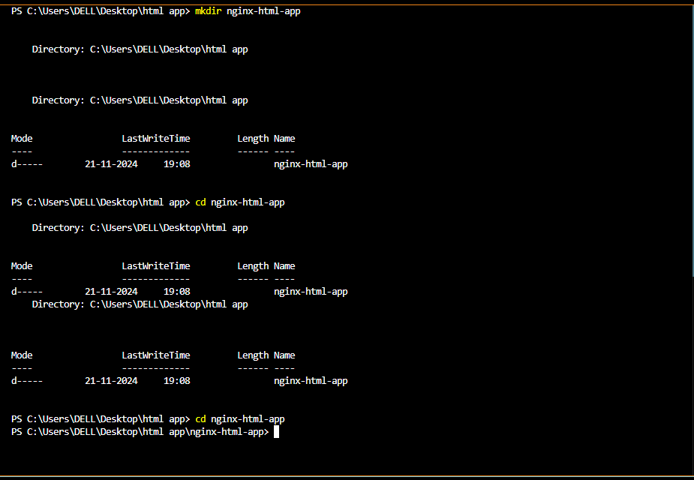

*Inside the nginx-html-app directory, create the HTML file.*

|  |
| --- |
| ***touch index.html*** |

*Edit the index.html file with the following content (or any custom HTML content you want):*

|  |
| --- |
| ***<!DOCTYPE html>***  ***<html>***  ***<head>***  ***<title>Welcome to My Nginx HTML App</title>***  ***</head>***  ***<body>***  ***<h1>Hello, Nginx Docker!</h1>***  ***<p>This is a simple HTML app served by Nginx in a Docker container.</p>***  ***</body>***  ***</html>*** |

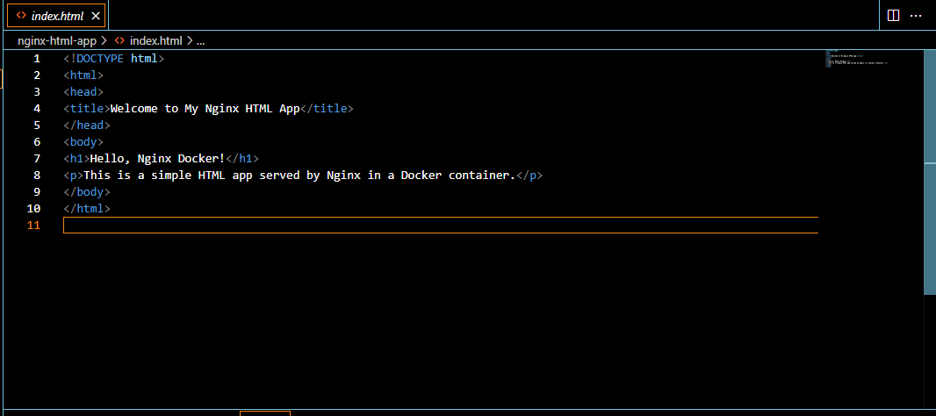

***3. Step 2: Create a Dockerfile***

*In the same directory, create a Dockerfile. This file will define how to build the Docker image using Nginx as the base image.*

|  |
| --- |
| ***touch Dockerfile*** |

***Edit the Dockerfile and add the following content:***

|  |
| --- |
| ***FROM nginx:latest***  ***COPY index.html /usr/share/nginx/html/***  ***EXPOSE 80*** |

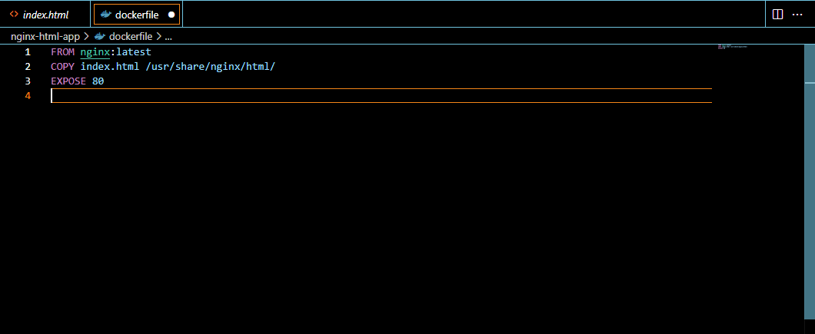

***. Step 3: Build the Docker Image***

*Now that you have the Dockerfile and index.html, it’s time to build the Docker image.*

*Run the following command to build the image, giving it a tag (e.g., nginx-html-app):*

|  |
| --- |
| ***docker build -t nginx-html-app*** |

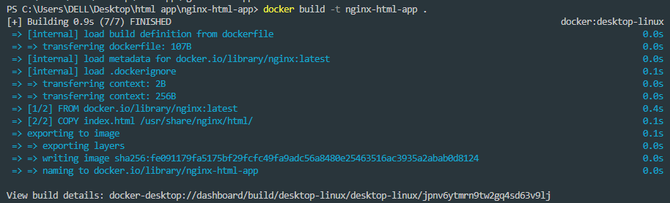

*Docker will use the Nginx base image, copy your index.html into the appropriate directory, and build the image.*

***5. Step 4: Run the Docker Container***

*After building the image, you can run the container with the following command:*

|  |
| --- |
| ***docker run -d -p 8080:80 nginx-html-app*** |



*This command runs the container in detached mode (-d) and maps port 8080 on your host machine to port 80 inside the container, where Nginx is serving your HTML app.*

***6. Step 5: Verify***

*Open a browser and go to http://localhost:8080. You should see your HTML page with the message “Hello, Nginx Docker!”.*

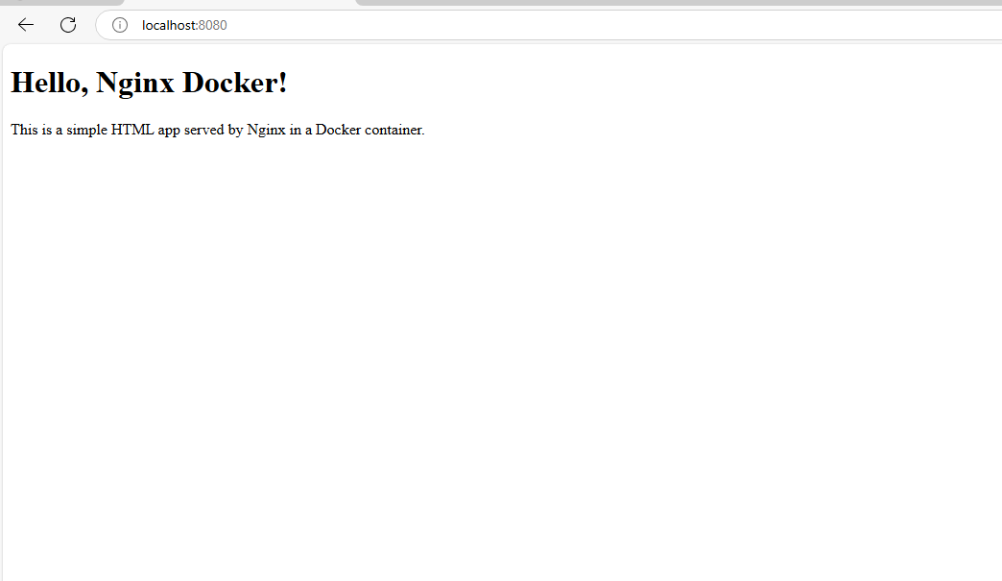

***7. Step 6: Stop and Remove the Container***

*Once you're done, you can stop and remove the container:*

|  |
| --- |
| ***docker ps # to see running containers***  ***docker stop <container-id>***  ***docker rm <container-id>*** |

